Python:

a=2000

b=3200

for i in range(a,b+1):

if (i%7==0 and i%5 !=0):

print (i)

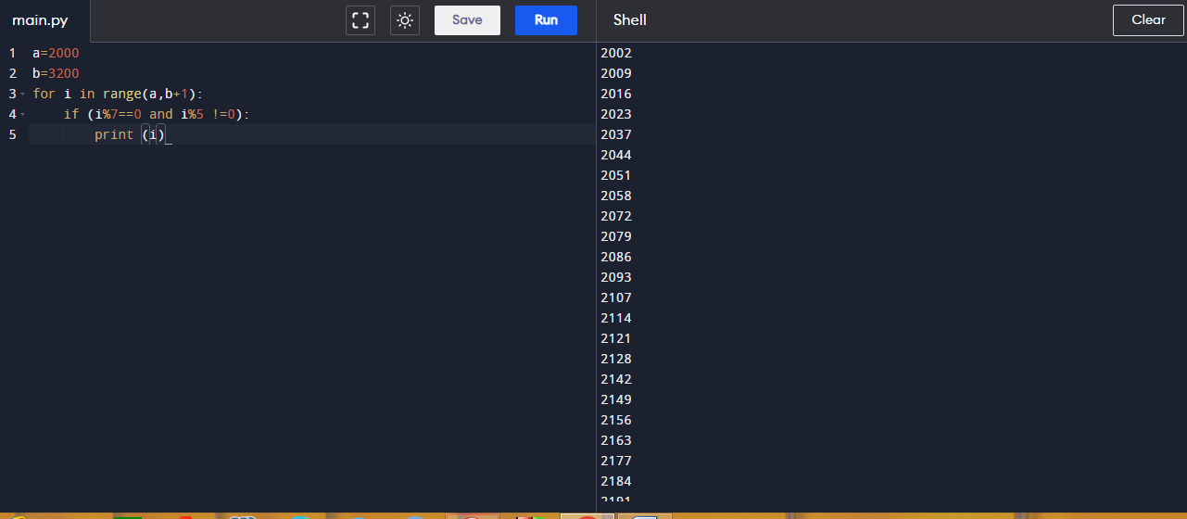

C-programming:

#include <stdio.h>

int main() {

for(int i=2000;i<=3200;i++)

{

if(i %7==0 & i %5 !=0)

{

printf("%d\t",i);

}

}

return 0;

}

Output:

